Data Loading Reference Document

For

AIM HealthCare - Data Loading

Prepared By
Srivathsan K & Vani Murarka

Version 0.6
Documentation Location
Repository | CVS
Location
Document

Revision History

Issue No. | Date | Author | Action | Changes
0.1 | Feb 1, 2006 | Srivathsan | Initial Draft
0.2 | Feb 16, 2006 | Srivathsan | Updates | Added Section 2.1.1 Loading data onto adhoc database (a-g)  Added Section 2.1.2 Loading data onto Racer database (a-e)
0.3 | Feb 28, 2006 | Vani | Updates | Added explanation for Setting up Local Dev Environment, Prepare, Split
0.4 | Feb 28, 2006 | Srivathsan | Updates | Sections re-organized and section 2.2 Client data guide Introduced. Section 2.3 Adhoc Loading Introduced.
0.5 | 2 March 2006 | Vani | Updates | Split logic for Claim Header and Line.
0.6 | 18 March 2006 | Vani | Updates | New Split Logic for Claim Header

Distribution
Issue No. | Distribution Audience
0.1 | Team Members
0.2 | Team Members
0.3 | Team Members
0.4 | Team Members

1 Introduction 4
1.1 Purpose 4
1.2 References 4
2 Overview 4
2.1 Setting up Development Environment 5
2.1.1 Step 1 – Create composite solution 5
2.1.2 Step 2 – Setup Databases 6
2.1.3 Step 3 - Change code for ETL to connect to new Development DB Server 6
2.1.4 Step 4 - Create central file store for Input Output files 6
2.1.5 Step 5 - Create new Project in EnterpriseMetaData 6
2.1.6 Step 6 - Run ETL Application and create new JobID 6
2.1.7 Step 7 – Specify Raw File Location 7
2.1.8 Step 8 – Run ETL 7
2.2 Client Data Guide 7
2.3 Adhoc Loading 8
2.4 Preprocess 9
2.5 Prepare 10
2.6 Split 10
2.6.1 Basic logic for any Split 12
2.6.2 Suggested implementation for GHI PPO as per CDG 12
2.6.3 Suggested steps for Claim Header Logic 1: 13
2.6.4 Suggested steps for Claim Line Logic 1: 13
2.6.5 Suggested steps for Member Logic 1: 14
2.6.6 Suggested steps for Claim Header Logic 2: 14
2.6.7 Suggested steps for Claim Line Logic 2: 14
2.6.8 Suggested steps for Provider Logic 1: 14
2.6.9 Suggested steps for Insurance Group Logic 1: 15
2.6.10 Suggested steps for Claim Header Logic 3: 15

Introduction

Purpose
The objective of this document is to share information with team members on the way how data is manipulated for the client “Empire”. The process of loading data from source on to AIM Health Racer Database has different phases and they are as follows.
- Preprocess
- Prepare
- Split
- Integrate
- Load
- NetChange

References
Please refer RacerLoad.vsd visio diagram.
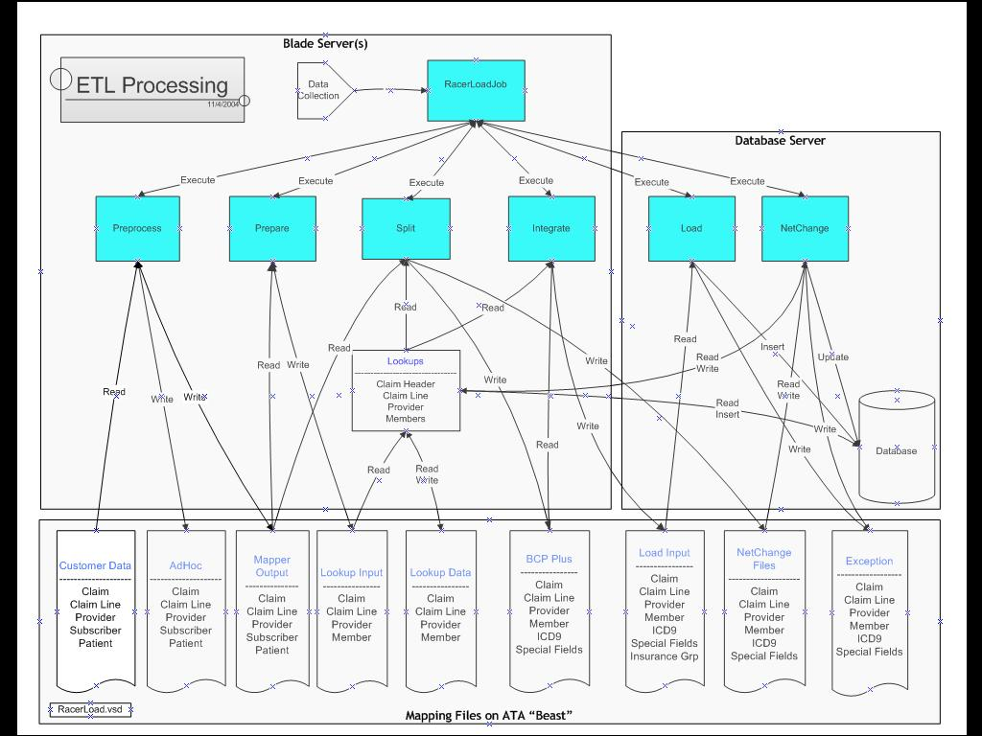

Overview
This section has information listed phase wise and we will be looking at the code files related to empire.
- AIMHealth.DMInfrastructure.Load.Framework.Interfaces.PreProcess
  - PreprocessClaimHeader0002.cs
  - PreprocessClaimLine0002.cs
  - PreprocessProvider0002.cs
  - PreprocessSubscriber0002.cs
  - PreprocessPatient0002.cs
  - PreprocessInsuranceGroup0002.cs
  - PreprocessMemberxxxx.cs
  - PreprocessProviderPinxxxx.cs
  - PreprocessSplit002.cs
  - PreProcessJobEngine.cs
  - PreProcessJobFactory.cs

Files marked in yellow needs to be checked for their intended useage.

Setting up Development Environment

Step 1 – Create composite solution

The complete solution should have the following 19 projects
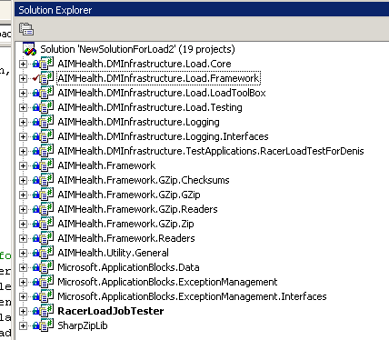

Where the RacerLoadJobTester should be the startup project.

Step 2 – Setup Databases

- On a central server [which will be the new Development Server], restore the EnterpriseMetaData database backup
- Create the RacerDev Database as per given script
- Grant db read/write access to developers who will be working in this environment. The ETL application connects to these DBs via Windows Authentication. Also, grant execution permission on stored procedure RaceLoadJobUpdate in EnterpriseMetaData DB.

Step 3 - Change code for ETL to connect to new Development DB Server

In RacerLoadJob.cs – In method GetRacerConnectionString(ConnProviderString passedConnProviderString), for the default case change the Data Source to the name of the new development server.

In RacerLoadJob.cs – In method GetEnterpriseMetadataConnectionString(ConnProviderString passedConnProviderString), for the default case change the Data Source to the name of the new development server.

Step 4 - Create central file store for Input Output files

On a central server, define a folder for holding all input output files for all Clients for this environment.

Share this folder for network access.

Create separate folders for each Client. Thus, for example, the following folder structure has been created:

AIMFiles\RacerFeeds\GHI-PPO\9999 [for Feed 9999]
And
AIMFiles\RacerFeeds\GHI-PPO\Raw [to hold raw files received from Client]

AIMFiles folder is shared.

Step 5 - Create new Project in EnterpriseMetaData

Enter new record for new Project / Client in ProjectMetaData table
Specify ProjectID – ProjectID assigned by AIM
PatSubLoadPrecedence – 0
FeedDirectoryName – the network share path to the folder for the relevant client. For example, value entered in this field as per Step 4: \\emids16\aimfiles\RacerFeeds\GHI_PPO where emids16 is the name of the central server holding the files.

Step 6 - Run ETL Application and create new JobID

Using the left side of this form in RacerLoadJobTester project:
i.e. enter assigned ProjectID, FeedID [normally 9999 for first tests], Server: Development Server.
Click Create New RacerLoadJob button.

Application will give the new JobID created.

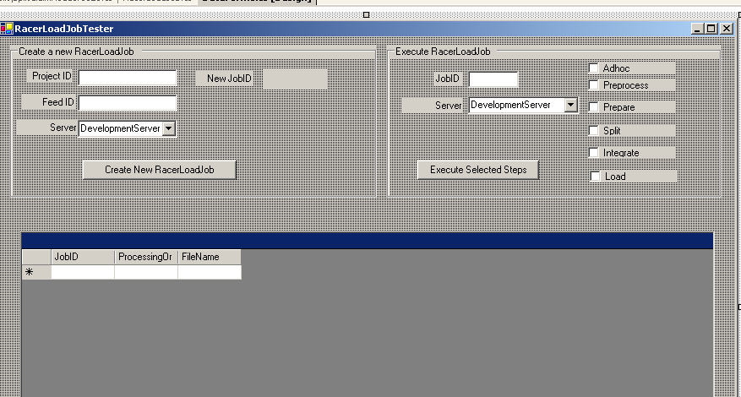

Step 7 – Specify Raw File Location

In JobRawFileAssoc table, in EnterpriseMetaData, for the new JobID created, enter new records, specifying the raw files to be used for each file type, with location pointing to appropriate folder in shared network path.

Step 8 – Run ETL

Run ETL via the Right side of the RacerLoadJobTester form, specifying new JobID, which has been created, and the stages of the ETL that you want to run.

Client Data Guide
Client data guide is core to the entire process of data loading. A quick summary of client data guide is given below. Please note Client data guide file is for all business users and all information need not be applicable for IT dept.

Worksheet “Loading and Integration”
This work sheet gives information for the IT Team about the data that should be loaded into the system. It also indicates the columns that the IT Team should look out to check these business constraints. Date Range, Claim Paid Amount & Additional Exclusion rows are of significance to the IT Team in this work sheet. However this business rules should not applicable in Adhoc Loading Phase.

Date Range → always refers DATE_PAID column in CF- Claim Header work sheet.

Claim Paid Amount → always refers to AMT_PAID column in CF- Claim Header work sheet.

Additional Exclusion if any is explicitly defined.

Worksheets starting with “AD”
This worksheet gives us data mapping information. It also has information about the data type, data length, data start and end position.

All work sheets that start with the name “AD” will be used in data loading against adhoc database.

Worksheets starting with “CF”
This worksheet gives us data mapping information. It also has information about the data type, data length, data start and end position.

All work sheets that start with the name “CF” will be used in loading data against Racer Database.

Worksheets starting with “LU”
Here the column “Client Field Name & List of Possible Values” indicates all potential values that you can expect from the data served by the client.

Now coming to “Client Field Values associated w/AIM field” Column. Any values from “Client Field Name & List of Possible Values” listed here will map to the AIM field.

All work sheets starting with name “LU” can be used in loading data against Racer/Adhoc Database

Worksheets in Green Color
Adjustment Logic and Adjustment logic examples are the work sheets that are of interest to the IT Team.

Business rules defined in Adjustment logic is applied to the data during “Split” Phase of data loading against Racer database.

Adjustment Logic work sheet is used in loading data against Racer Database

Worksheet “Essential Racer Elements”
This sheet indicates the essential information that is required in Racer database when Claim Header Data is loaded. (Please note: Refer this sheet only for Claim Header “Racer Req” column)

Adhoc Loading
The objective of this loading is to assist claim analysts who in turn will determine whether it is worth working taking up and working on the data supplied by the carrier. If a decision is made to work on the data supplied by the carrier then “Racer” database loading phase commences.

- Information from client is loaded onto Adhoc database without any additional processing i.e. data is loaded as it is received from the carrier.
- Client data guide worksheets will have information about adhoc data that should be loaded in the database. (Work sheets with prefix “AD” to their work sheet name)
- Worksheets prefixed with AD to their work sheet will have mapping information about the data.
- Adhoc database tables will have same columns as indicated in the worksheet. (Column “Ad-Hoc Fields”
- To load data onto adhoc database; raw data is used to prepare flat files. These flat files are delimited by “|”. First row represents the columns names. All Ad-Hoc fields data in worksheets marked as “AD” is moved to flat file.
- There’s no standard layout for the flat files generated during adhoc process. So we read the columns as they are in Client data guide and write out the same.
- Developers should make use of methods provided in “LoadAdhocTableFromTextFile.cs” to move data from flat files to adhoc tables.

Preprocess
Preprocess is the first stage in the data loading process when it has been decided by the claim analysts to load data on to Racer database. During preprocess and other following phases, various flat files are generated.

Loading data onto Racer database is slightly different from adhoc loading.

- Format files for various flat files that need to be generated are defined. So this means we have to extract data in the format/layout specified and store accordingly.

- You may have to calculate a piece of data with two other pieces of information. And this will be indicated in client data guide.

- Work sheets marked with prefix “CF” should be referred by the team involved moving data to Racer database.

- Apart from the work sheets prefixed “CF”; which gets generated as flat files, we may have to create additional text files as output.

  - How do I know about the flat files that I need to generate?
    - Normally the following flat files are generated (as applicable)
        - Claim Header
          - If you see column “Racer Table” with value “CLM” in worksheets prefixed “CF” with their name then you have create this flat file.
        - Claim Line
          - If you see column “Racer Table” with value “CLIN” in the worksheets prefixed “CF” then you have to create this file.
        - ICD 9
          - If you see column “Racer Table” with value “ICD 9” in the worksheets prefixed “CF” then you have to create this file
        - Special Fields
          - If you see column “Racer Table” with value “Special Fields” in the worksheets prefixed “CF” then you have to create this file
        - Member
          - If you see column “Racer Table” with value “MEM” in the worksheets prefixed “CF” then you have to create this file
        - Subscriber
          - If you see column “Racer Table” with value “SUBS” in the worksheets prefixed “CF” then you have to create this file
        - Patient
          - If you see column “Racer Table” with value “PAT” in the worksheets prefixed “CF” then you have to create this file
        - Provider
          - If you see column “Racer Table” with value “PROV” in the worksheets prefixed “CF” then you have to create this file
        - Insurance Group
          - If you see column “Racer Table” with value “INS” in the worksheets prefixed “CF” then you have to create this file
  - Is there any additional field required in the flat files apart from the standard list?
    - Refer Worksheet “Essential Racer Elements” in client data guide. For e.g list of elements that would need in Racer database are maked “Y” in the column “Racer Req”. So if you have not loaded data which is marked “Y” in this sheet then you have that information in the flat file that you generate. You would need to see only “Racer Req” here. Not others. This is applicable only for Claim Header part.

- In this process you always generate format files for every output file(s) first. After that you may have to look up other data set(s) to fetch information during the process of creating flat file.

Prepare

This is the stage after PreProcess on all data sections have been completed.

Once all PreProcess routines have been executed on all the data sections – Claim Header, Claim Line, Provider, ICD9 etc., it is the first time in the ETL that all the data files are available as MapperOutput files for it to be possible to perform some combined processing upon them.

The Prepare stage essentially creates LookUp files. These LookUp files are different from the code LookUp of RelToInsured and PlaceOfService etc. referred to in PreProcess.

These Lookup files are files containing only identifying columns from ClaimHeader, ClaimLine etc., sorted in a particular order, as per the requirements of the subsequent stage: Split.

Thus, for example -

A ClaimHeader mapper output may be used to create a lookupDataClaimHeader file as follows:
Sorted on CLAIM_NO
Output Columns CLAIM_NO
Duplicate Processing OutputFirstFoundOnlyDupsAndUniques

A ClaimLine mapper output may be used to create a lookupDataClaimLine as follows:
Sorted on CLAIM_NO, ClaimLineAdjCode, ClaimSubLineNo
Output Columns CLAIM_NO, ClaimLineNo
Duplicate Processing OutputFirstFoundOnlyDupsAndUniques as identified by CLAIM_NO, ClaimLineAdjCode, ClaimSubLineNo

The required processing in Split determines the lookup file that Prepare should create [which columns the sorting should be on, which columns are to be output in the lookup file, what the duplicate processing should be]

Split

The Split stage is essentially about dividing records into two buckets – BcpPlus and NetChange.

Different cs for different data sections – ClaimHeader, ClaimLine, Patient, ICD9 etc.

Input Files:
The relevant MapperOutput as created in PreProcess

Outputs: -
BCP Output
NetChange Output
Disposition Output – which marks which record is to be handled in which manner [BCP / NetChange]

Claim Header:
Each record in the mapper output file [which is an input to this stage] is read, and
- the read ClaimNo is compared against the ClaimNo of the previous record
- the read ClaimNo is looked for in the lookup created in Prepare stage

If the current ClaimNo is different from the previous
And the ClaimNo is not found in the Lookup
And Current ClaimNo does not start with “M” --- adjustment logic defined for BCBS_FL in CDG
Read Record is written to BCP Output
Entry is made for the current ClaimNo in disposition with mark as BcpPlus
Else
Read Record is written to NetChange Output
Entry is made for the current ClaimNo in disposition with mark as NetChange

Thus all records from mapper output file, goes either into BCP Output or into NetChange Output

Claim Line:

// The claim header file is already sorted in order by claim_no.
// Since the disposition file was created from a sequential sweep
// through claim header, it too is in claim_no order.
// Claim line was also created in claim_no order in preprocess.
// So the disposition file and claim line file can be matched
// without sorting first

The Disposition file created in the Split ClaimHeader file is used. Mapper Output Claim Line file is read as input.

For each record read from Mapper Output Claim Line, the corresponding ClaimNo is searched for in the Disposition File.

If found, and Claim No in Disposition File is marked as BcpPlus, write Claim Line to ClaimLine BcpPlus output
If found, and Claim No in Disposition File is marked as NetChange, write Claim Line to ClaimLine NetChange output’
If ClaimLine from Mapper Output not found in Disposition File, write to exception file.

Thus, for all ClaimNos from Claim Header, which are in BcpPlus, the corresponding ClaimLines are put in the ClaimLineBcpPlus, and for all ClaimNos from Claim Header, which are in NetChange, the corresponding ClaimLines are put in the ClaimLineNetChange

In the case of 0025, there is no Prepare for ClaimLine since no lookup for ClaimLine is used for ClaimLine Split.

Important:
The lookup file created by Prepare is not used directly in Split. When lookup is used in Split, internally a lookupData file is created. This contains all claim numbers which are there in the original lookup [created by Prepare] AND are already there in the Racer DB. Thus, the lookupData file available to Split contains all claim numbers which are there in the input data and are already there in the Racer db from a previous full feed.

Basic logic for any Split

Any record which is a duplicate or an adjustment record should go into the NetChange bucket. Any brand new claim record [and related claim lines etc.] should be sent to BcpPlus.

The logic for identifying adjustment records differs from client to client. This logic is given in the Adjustment Logic Description sheet of the CDG. Examples as per the given logic is given in the Adjustment Logic Data Examples sheet.

As per specific logic of the relevant client, the logic of Split and Prepare should be formulated.

Suggested implementation for GHI PPO as per CDG

The logic for identifying Adjustment records for GHI PPO is given as follows:
Adjustments are identified using a combination of the CLAIM_SUFFIX and the ADJUSTMENT_CODE.
∙ CLAIM_SUFFIX '99' = original claim, '98' = 1st adjustment, '97' = 2nd adjustment, etc…
∙ ADJUSTMENT_CODE '1', '2', '7', and '8' are payments.
∙ ADJUSTMENT_CODE '3', '4', '6', and '9' are reversals.
Current feed:
1. Match by CLAIM_NO.
2. Load all claim header and claim line records containing:
a. The lowest value in CLAIM_SUFFIX.
b. ADJUSTMENT_CODE = '1', '2', '7', or '8'.
3. If the lowest CLAIM_SUFFIX on a CLAIM_NO only contains an ADJUSTMENT_CODE = '3', '4', '6', or '9', do not load any claim header or claim line records for that CLAIM_NO. (Example 4 and 5)

??? Need to understand what they mean by Current Feed and Later Feed and how that will affect things – maybe it will affect in a subsequent stage of the ETL and not in Split/Prepare?

Suggested steps for Claim Header Logic 1:
      - Sort MapperOutputClaimHeader in Preprocess or Prepare as per CLAIM_NO [Ascending] + CLAIM_SUFFIX [Descending]
      - Need to see whether we need to do anything with Lookup just now – maybe lookup against claim number + suffix – but current lookup class is not made for an additional field over and above claim no + suffix.

In Split –
[Assumming the following:
First record for a Claim No with 99 suffix, irrespective of adjustment code value [1,2,7,8 set of 3,4,6,9] should go into BcpPlus
Last record for a claim number with lowest suffix 1,2,7 or 8 should go into NetChange
Intermediate records and records with adjustment code = 3,4,6,9 to be discarded – to be confirmed]
      - Read record from sorted mapper output and note claim number and suffix.
If suffix = 99 and claim number != prev claim number and suffix != prev suffix and claim_number
Put record in BcpPlus
Record claim number and suffix in Disposition file, with marking “BcpPlus”
To check – what is to be done when there is no record for that claim number with suffix 99 [example 3 in CDG]
Else
keep the whole record noted in memory
[may have to be written in the next step]

      - Read next record.
If claim number = prev record
If suffix < prev record
replace prev record and keep this new one in memory for
comparision against the next
If suffix = prev record – duplicate
put in NetChange
Record claim number and suffix in Disposition file, with marking “NetChange”
Else – new claim number encountered
if prev record suffix = 1,2,7 or 8
put in NetChange
Record claim number and suffix in Disposition file, with marking “NetChange”
else
ignore prev record
apply logic of Step 3 to new record.

Suggested steps for Claim Line Logic 1:

  - Sort ClaimLine MapperOutput in ClaimNo + ClaimSuffix + LineNo order in Prepare or PreProcess
  - Read ClaimLine record by record
Note ClaimNo and ClaimSuffix in memory.
  - If ClaimNo and Suffix same as prev record
Disposition mark will already be available in memory
Else
Check for corresponding ClaimNo and ClaimSuffix in Disposition
file created in ClaimHeader Split.
Note whether the Disposition is marked for BcpPlus or NetChange for this
ClaimNo + Suffix and keep in memory
If ClaimNo and Suffix not found in Disposition
Ignore ClaimLine record, go to step 2
  - If Disposition marked for BcpPlus
write ClaimLine record to ClaimLine BcpPlus
Else
write ClaimLine record to ClaimLine NetChange

Suggested steps for Member Logic 1:

Basically, it seems, for Member, Split can work in essentially the same way as in the case of 0025 [BCBS_FL]

Still have to explain the steps nevertheless

Suggested steps for Claim Header Logic 2:

- Sort MapperOutputClaimHeader in Prepare as per:
  - ClaimNo (asc)
  - ClaimSuffix (desc)
  - Adjustment Code (desc)
- In Split: For each record
  - If Claim Suffix == 99 && ClaimNo != previous Claim No && adjustment code in (1,2,7,8)
    - Put record in BcpPlus
    - Write claim number, suffix, adjustment code to disposition with marking “BcpPlus”
  - Else if adjustment code in (1,2,7,8)
    - Put record in NetChange
    - Write claim number, suffix, adjustment code to disposition with marking “NetChange”

Suggested steps for Claim Line Logic 2:
- Sort MapperOutputClaimLine in Prepare as per:
  - ClaimNo (asc)
  - ClaimSuffix (desc)
  - Adjustment Code (desc)
- In Split: For each record
  - Read claim number, suffix, adjustment code and look for corresponding claim number, suffix, adjustment code in Disposition [created in Claim Header Split]
    - If Disposition marked as BcpPlus, put record in ClaimLineBcpPlus
    - Else put record in ClaimLineNetChange

Suggested steps for Provider Logic 1:

- In Prepare sort MapperOutputProvider as per:
  - Provider_No [In some clients Provider is also additionally sorted by TAX_ID, but in GHI PPO, TAX ID is blank, hence not including this in the sorting]
- Whether Prepare should create the Lookup file also or not – needs to be discussed with Srivathsan – since we are not doing Lookup for ClaimHeader etc just now, do we take the same approach for Provider? I think there is no harm in making the Lookup file also in Prepare for Provider.

Suggested steps for Insurance Group Logic 1:

- In Prepare sort MapperOutputInsuranceGroup as per:
  - INS_GROUP_NO [anyway there is no other column with data in Insurance Group]
- Whether Prepare should create the Lookup file also or not – needs to be discussed with Srivathsan – since we are not doing Lookup for ClaimHeader etc just now, do we take the same approach for Insurance Group? I think there is no harm in making the Lookup file also in Prepare for Insurance Group.

Suggested steps for Claim Header Logic 3:

- Sort MapperOutput in Prepare as per:
  - Claim No [ascending]
  - Claim Suffix [ascending] [most recent record for that claim number will be the first record]
  - Adj Code [desc]
- In Split:
variables required:
  - Bool AlreadyWritten = false
- For each record read from MapperOutput
If Adj Code == 1,2,7 or 8
{
If AlreadyWritten == true
{
If ClaimNo != PrevClaimNo [new set of claim numbers now]
AlreadyWritten = false
}
If AlreadyWritten == false
{
Look for ClaimNo in LookupData
If Found [record already exists in RacerDev]
{
Put record in NetChange
Write claim number, suffix and adj code to disposition with “NetChange” mark
AlreadyWritten = true
}
else [new rec for RacerDev]
{
Put record in BcpPlus
Write claim number, suffix and adj code to disposition with “BcpPlus” mark
AlreadyWritten = true
}
}

